**Project Ideas**

**for**

**MSc Students**

**User Interaction Design**

**By**

**UP687776**

Table of Contents

1. Introduction 3

2. Sitemap 3

3. Wireframe Design 3

4. Use Case Diagram 6

# **Introduction**

This document will contain user interaction design including sitemap, wireframe and use case diagram.

# **Sitemap**

The purpose of creating sitemap design is to clarify the content this website will have like creating, adding, updating and retrieving user data, and project ideas. The focus is to reduce number of pages on this web application for users to navigate around with having functionality on same page.

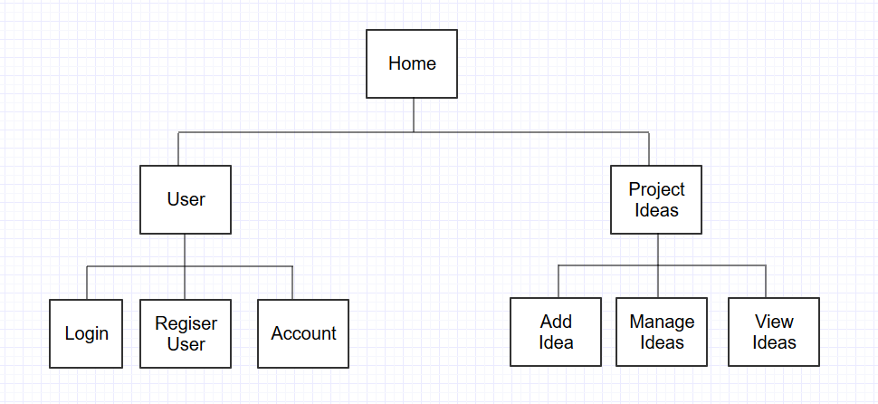

# **Wireframe Design**

* 1. Index Page

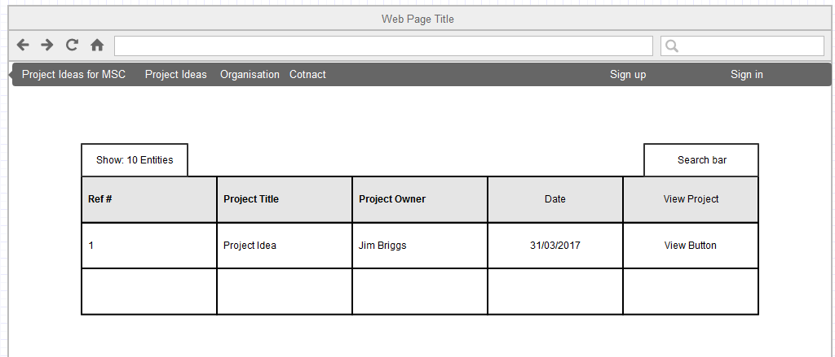

This page will allow users to view, idea, search idea, and login.

* 1. Create/Edit Project Idea

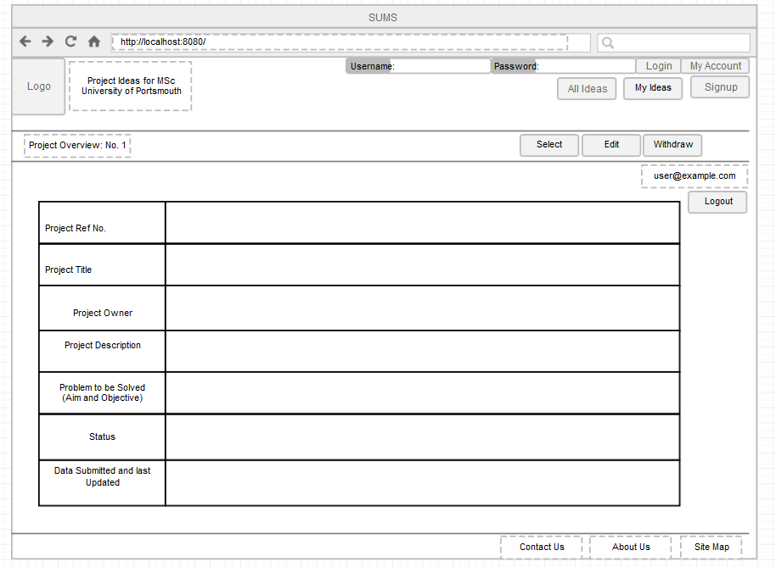

Submit

This page will allow privileged users to create, edit, update, select, and withdraw ideas.

|  |  |
| --- | --- |
| * 1. Register Idea     This form will allow user to Register users and select type of user i.e. Student, Admin, Tutor etc. | This form will allow user to login to the website, allowing them to have more access to features. |
| * 1. Create/Edit Project Idea   This form will allow users to create and edit project ideas | * 1. Contact Admin / Support     This form will allow users to create and edit project ideas |
| * 1. Create / Edit Organisation Form   This Form will allow previledged users to create an organisation. |

# Use Case Diagram

The following use case diagram will show how users (student and staff) will interact with the system.

